**2-3 Buffer Overflow Coding**

Jessica Ayer

November 4th, 2022

CS 405: 22EW2

Instructor: Aaron Demory

The original code made space in the register for a character with a length of 20 but there was no validation in place to make sure the user entered appropriate input. I switched the cin statement to a cin.getline which does not require a fixed length however, I set it to a 20 character count limit so that as the user_input variable has a fixed length. I then used an if statement to check for failed input. If failed input (input longer than 20 characters) was detected an error message is displayed and the potentially harmful input is cleared. If valid input was entered then the user input and their account number are displayed.

**Invalid Input:**

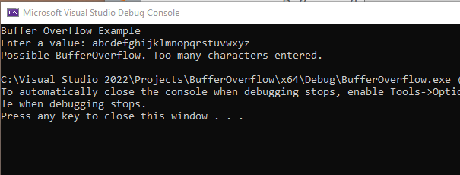

**Valid Input:**

